**Sales analysis**

**Data Model Diagram: -**

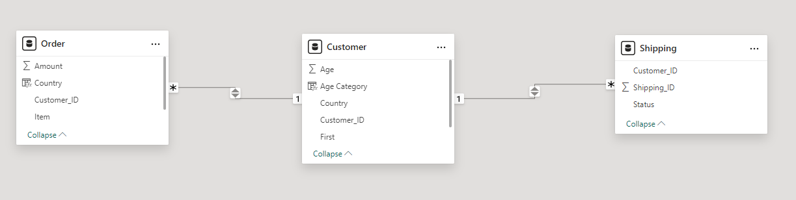

***1.the total amount spent and the country for the Pending delivery status for each country.***

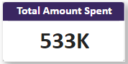

The total amount spent overall is 5,32,500 (533K)

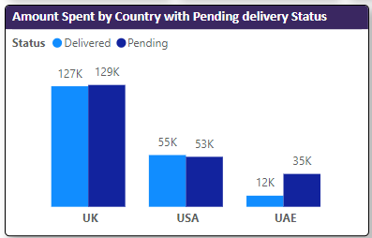

the country for the Pending delivery status for each country.

The above Visual will provide breakdown of Amount spent by country wise and split by Delivery status.

**Observation**:- UAE has 73% of amount with delivery status as pending , while rest of the countries has almost equal share of amount for both delivery status.

***2.the total number of transactions, total quantity sold, and total amount spent for each customer, along with the product details.***

***Assumptions:-***

1) Each order id is considered as transaction , so for total number of transactions count of order ID is considered

2) Quantity column is missing in the data so each order ID is considered as having quantity 1

**Note**:- For the 2nd question these are assumptions followed for missing data and if any data issues ready to take the assessment.

***the total number of transactions***

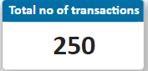

There are totally 250 order id’s and considering each ID as a transaction we have totally 250 Transactions.

***total quantity sold,***

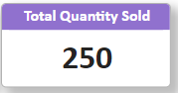

We don’t have column that as details about quantity sold so assuming each order ID has one quantity we have total quantity sold as 250

***and total amount spent for each customer, along with the product details.***

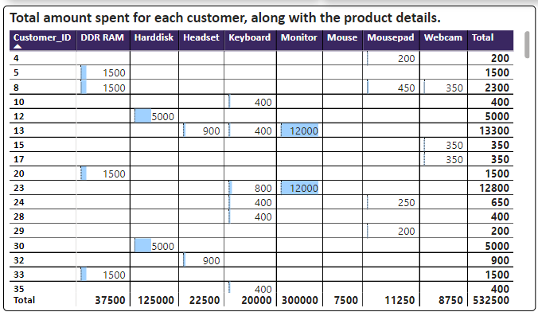

The above matrix table is created understand amount spent by each customer by product.

**Observation**:-

1. Highest amount is generated by Monitor
2. Costumer ID 166,123,129 contributed to highest amount.

***3.the maximum product purchased for each country.***

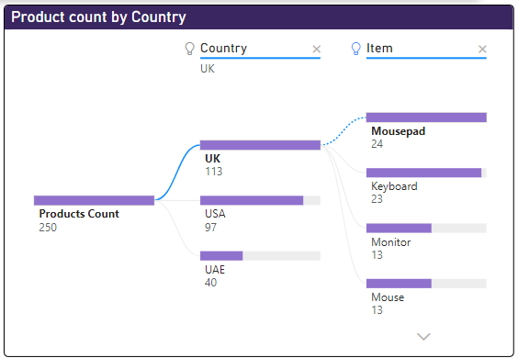

The above Decomposition tree is created understand the product count from each country.

**Observations**:-

UK has highest quantity of product count (113).

Mousepad(24), Key boards(23) are the highest products sold which contributing to 42% of products.

USA has second highest quantity of product count (97)

Mousepad(18), Key boards(15) are the highest products sold which contributing to 34% of products.

USA has Third highest quantity of product count (40)

Key boards(12), Mousepad(8) are the highest products sold which contributing to 50% of products.

***4.the most purchased product based on the age category less than 30 and above 30***

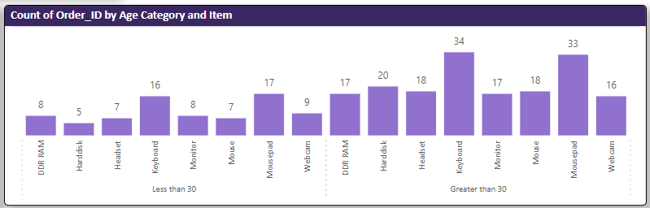

**Observation:-**

In less than 30 category Mousepad and Keyboard are highest

In greater than 30 category Keyboard and Mousepad are highest.

***5.the country that had minimum transactions and sales amount.***

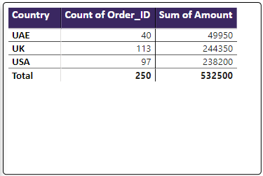

UAE has minimum transactions and sales amount